**Project Design Phase**

**Solution Architecture**

|  |  |
| --- | --- |
| Date | 26 -052025 |
| Team ID | LTVIP2025TMID61039 |
| Project Name | Rental Home :Find Your Perfect Home |
| Maximum Marks | 4 Marks |

**Solution Architecture:**

**1. Technical Scalability**

**Here’s a structured explanation of the Scalability of the Solution for your Rental Home Finder Project 👇**

**---**

**📈 Scalability of the Solution**

**1. Technical Scalability**

**Cloud-Based Architecture → Hosting on AWS/Azure ensures the platform can handle growing traffic and data without downtime.**

**Modular Microservices Design → Each core function (search, payments, chat, notifications) can scale independently.**

**Database Scalability → Use of PostgreSQL/MongoDB with replication and sharding to support millions of property listings and users.**

**Cross-Platform Expansion → Built on React/Flutter → easily extended across web, iOS, and Android.**

**---**

**2. Market Scalability**

**Geographic Expansion → Start in one city/region → expand to multiple cities, states, and eventually international markets.**

**Multi-Segment Support → Initially focus on rental homes → extend to PGs, hostels, co-living spaces, vacation rentals, and commercial properties.**

**Partnership Growth → Collaborations with universities, corporates, and real estate agencies for bulk tenant/landlord onboarding.**

**---**

**3. Business Scalability**

**Revenue Growth → Expand income streams beyond subscriptions and commissions → include partnerships (furniture, movers, internet providers, insurance).**

**Automation → AI-driven property recommendations, fraud detection, and automated verification reduce operational costs as users grow.**

**Data-Driven Insights → As listings and transactions increase, the platform can offer premium market analytics reports to landlords and agencies.**

**---**

**4. User Scalability**

**For Tenants → More verified listings, faster recommendations, and secure transactions as the user base grows.**

**For Landlords → Larger tenant pool, faster occupancy rates, and better lead quality.**

**For Admins → Automated monitoring dashboards reduce workload even with platform expansion.**

**Example - Solution Architecture Diagram:**

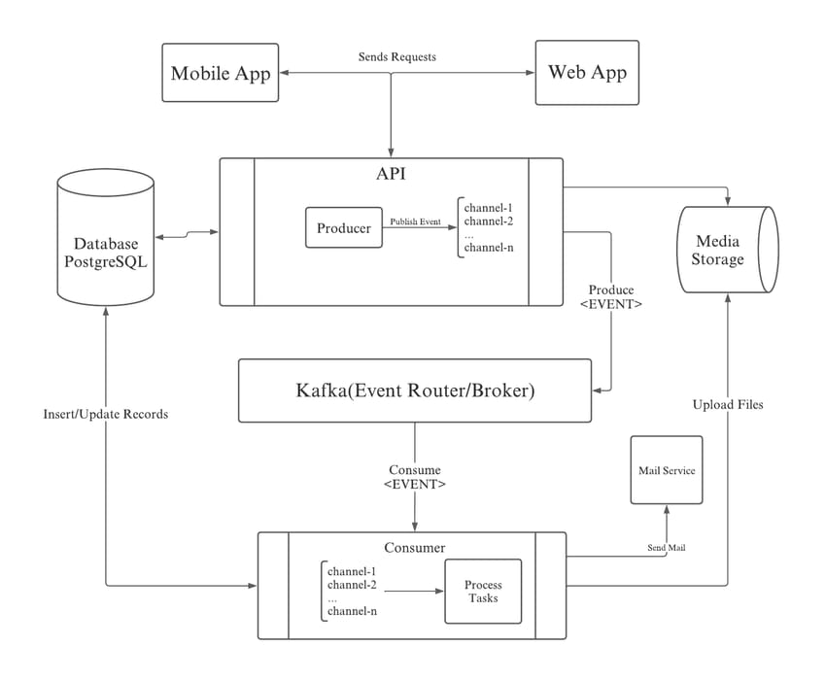

**Reference**

<https://aws.amazon.com/blogs/industries/voice-applications-in-clinical-research-powered-by->

ai-on-aws-part-1-architecture-and-design-considerations/